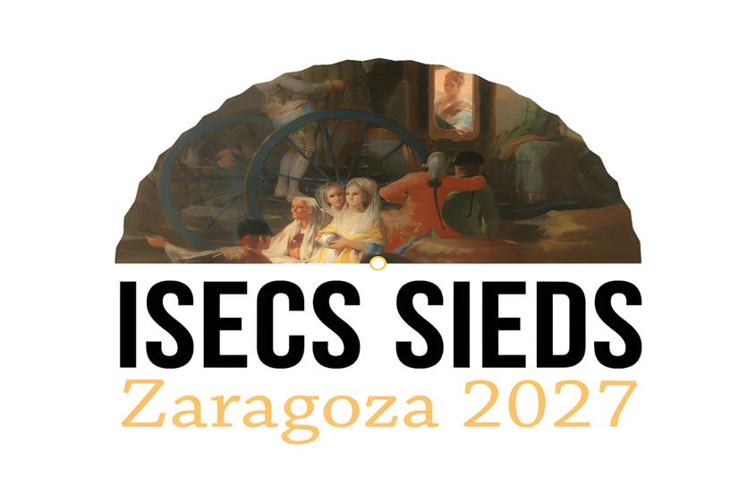

17th Congress of the
international society for eighteenth-century studies (ISECS)
ZARAGOZA, SPAIN, 12-16 JULY 2027

BURSARIES – Application form

Deadline
31 December 2026

Please submit completed application form by the deadline of 31 December 2026 to bursaries@isecs-zaragoza2027.net

IMPORTANT: Please note
Priority for bursaries will be given to those intending to present papers at the Zaragoza Congress who fall into the categories of: postgraduate students, early career scholars, colleagues facing unusually high travel costs, and those coming from traditionally underrepresented minority groups.

SUBJECT OF PRESENTATION TO CONGRESS
Your name and email address (please print clearly!)

Title of presentation:

Name of panel in which presentation appears (if known):
Brief summary of presentation (100 words max):
PERSONAL INFORMATION

Please note that early career researchers are not expected to have information
under every heading of this form

First name(s) | Last name(s)
Nationality

Please indicate current academic and/or professional situation, and identify name of department and institution
Doctoral student □ Postdoctoral researcher □ Lecturer □
Assistant Professor □ Professor □ Other, including freelance (please specify):

Department and institution:

Degrees (starting with most recent, including discipline and awarding institution):
Up to three publication(s) relevant to your presentation, if any (starting with most recent):
Other personal information, including minority group identity (please use your judgment as to what is relevant here):

ESTIMATED FINANCIAL NEEDS

Please translate local currencies into Euros, using a currency converter such as https://www.xe.com/currencyconverter/

Please note also that it is not necessary to claim under every heading and that bursaries may be awarded for either the whole or part of the sum requested
Place of origin for journey to Zaragoza:
BUDGET DETAILS Estimated cost of transportation
A Plane / Flight from airport of origin to Zaragoza (return) |  |  | (Euros)
B Rail / Transport from station of origin to Zaragoza (return) |  |  | (Euros)
C. Other essential transportation costs (please specify) |  |  | (Euros)
Total costs of transportation |  |  | (Euros)
Registration fee for Rome Congress:  Until 31 March 2023 = € 325,00; after 31 March 2023 - € 375,00  Student, retired and unwaged = € 200,00 |  |  | (Euros)
TOTAL SUM REQUESTED: |  |  | (Euros)
Any other unavoidable costs for which help is sought : (please specify) |  |  | (Euros)
Letter of recommendation

Your application must be accompanied by a letter of recommendation. This letter is to be no longer than one side of A4 (preferably in 12-point Times New Roman, with 1.5 line spacing) and must be written by a senior scholar who is well acquainted with your research and publications

The letter must cover the following points:
- knowledge of the applicant
- originality and quality of applicant’s work
- importance of presentation to applicant’s academic and career path
- applicant’s mastery of the language in which he/she wishes to make presentation

It must also include the following information:
- the name of the candidate, clearly shown at the head of the page
- place and date of sending
- about the referee :
- full first and last name(s) and title(s)
- current position(s), including department and institution.

The letter of recommendation should be submitted by the referee DIRECTLY to the selection committee, with a clear mention of the name of the applicant, before the deadline of 6 December 2026. Emails should be sent to isecsbursaries@isecs-zaragoza2027.net – indicating the subject as Letter of Recommendation.

Final note: ISECS warmly thanks all referees for their collegial support.
.

Please use 12-point Times New Roman and 1.5 line spacing. Do not exceed the space provided.
Please use12-point Times New Roman and 1.5 line spacing. Do not exceed the space provided. And please precede each entry with a hyphen.

